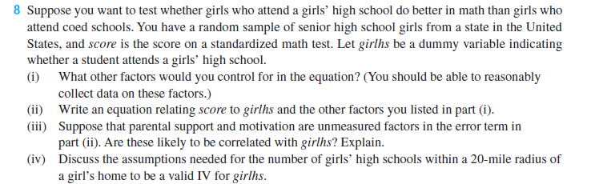

(i) A few examples include family income and background variables, such as parents’ education.

(ii) The population model is

score = β₀ + β₁girlhs + β₂faminc + β₃meduc + β₄feduc + u₁,

where the variables are self-explanatory.

(iii) Parents who are supportive and motivated to have their daughters do well in school may also be more likely to enroll their daughters in a girls’ high school. It seems likely that girlhs and u₁ are correlated.

(iv) Let numghs be the number of girls’ high schools within a 20-mile radius of a girl’s home. To be a valid IV for girlhs, numghs must satisfy two requirements: it must be uncorrelated with u₁ and it must be partially correlated with girlhs. The second requirement probably holds, and can be tested by estimating the reduced form

girlhs = π₀ + π₁faminc + π₂meduc + π₃feduc + π₄numghs + v₂

and testing numghs for statistical significance. The first requirement is more problematical. Girls’ high schools tend to locate in areas where there is a demand, and this demand can reflect the seriousness with which people in the community view education. Some areas of a state have better students on average for reasons unrelated to family income and parents’ education, and these reasons might be correlated with numghs. One possibility is to include community-level variables that can control for differences across communities.

